

**24 – 28 SEPTEMBER, 2025**

**TIMIRYAzEV Exhibition Center**

**Moscow, Verkhnyaya Alley, 8,**

**SPACE APPLICATION FORM**

|  |  |  |  |  |  |  |  |  |  |  |
| --- | --- | --- | --- | --- | --- | --- | --- | --- | --- | --- |
| **COMPANY NAME:** |  | | | | | | | | | |
| **BRAND NAME:** |  | | | | | | | | | |
| **POST CODE:** |  | **COUNTRY:** | |  | | | **CITY:** |  | | |
| **PO BOX CODE & STREET:** |  | | | | | | | | | |
| **TEL.:** |  | **FAX.:** |  | | | | **CELL:** |  | | |
| **E-MAIL:** |  | | | | | | | | | |
| **BANK NAME:** |  | | | | **BRANCH NAME:** | |  | | | |
| **IBAN:** |  | | | | **SWIFT:** | |  | | | |
| **ACCOUNT NUMBER:** |  | | | | | | | | | |
| **RESPONSIBLE PERSON:** |  | | | | | | | | | |
| **JOB TITLE:** |  | | | | | | | | | |
| **PRODUCTS TO BE EXHIBITED:** |  | | | | | | | | | |
| **MARK COMPANY TYPE:** |  | **PRODUCER** | |  | | **WHOLESALER** | | |  |  |

|  |  |  |  |
| --- | --- | --- | --- |
| **389EUR\***  (per 1 sq.m.) |  |  |  |
| **EQUIPPED SPACE:** |  | **SQM** |
| **MINIMUM size is 9 sq.m.** |  |  |

|  |  |  |  |
| --- | --- | --- | --- |
| **310EUR\***  (per 1 sq.m.) |  |  |  |
| **UNEQUIPPED SPACE:** |  | **SQM** |
| **MINIMUM size is 18 sq.m.** |  |  |

**OBLIGATORY REGISTRATION FEE 567 EUR** includes: registration of 5employees, company description in the Russian/English online application JUNWEX, 5 complimentary tickets.

**SURCHARGE FOR LOCATION:**

|  |  |  |  |  |  |  |  |
| --- | --- | --- | --- | --- | --- | --- | --- |
| **BOOTH**  **TYPES:** | **A (1 SIDE OPEN)** | **С (3 SIDE OPEN) — 15%** | **C** |  | **B** |  | **D** |
| **В (2 SIDE OPEN) — 10%** | **D (4 SIDE OPEN) — 20%** | **A** |  |  |

We hereby confirm our participation in the **JUNWEX MOSCOW 2025**

Authorized signature:_____________________ Stamp : ____________________Date:«_____» ___________202_

**PLEASE RETURN THIS FILLED FORM TO MEDIA-HOLDING JUNWEX**

E-mail: budnaya@mail.ru

Tel/Fax:+7 812 320 80 99 [**www.junwex.com**](http://www.junwex.com)

|  |
| --- |
| DEADLINE FOR APPLICATION IS **1 MAY 2025 !!!** |

*-prices in another currency shall be agreed with the Organizer.



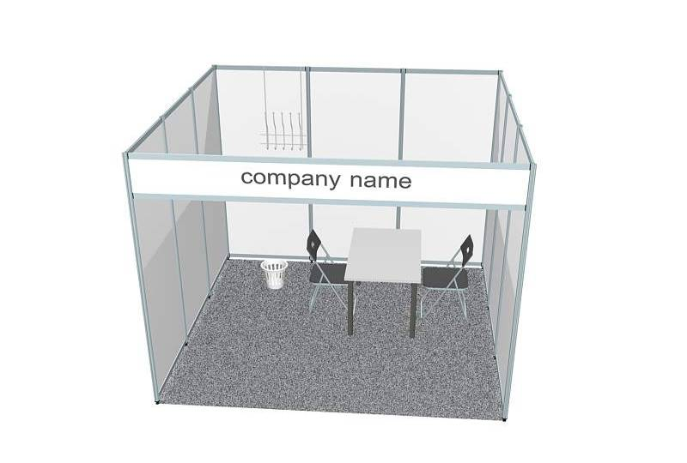

**SHELL SCHEME (built through Organisers)**

Standard shell scheme booth includes:

* exhibition stand of ordered size made of white wall panels 2500х1000х4 mm with aluminium profile
* carpet (grey)
* fascia panel
* fascia panel name – 10 characters total (Cyrillic or Latin) free of charge (extra characters are to be paid. Don’t forget to order according to number of open sides)
* 1 table (670х670 cm)
* 2 chairs (black)
* 1 waste basket
* 1 coat rack fixed to wall
* 1 spot light (reflector lamp 100W)

**Please note:** Electrical consumption and plug sockets **are not included** in the shell scheme and need to be ordered separately